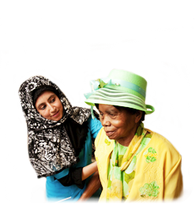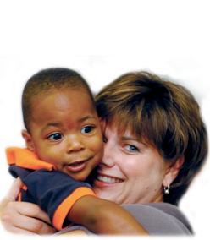**Tell us about your experience of using Adult Social Care Services in Kirklees and Calderdale?**

If you want to get involved, please contact Clare at Healthwatch Kirklees on either **01924 450379**, or email **clare.costello@healthwatchkirklees.co.uk**

We won’t ask for more than a short, regular phone call, at a time that’s best for you, or we can contact you by email or arrange a meeting if you prefer.

**We want to hear from adults or carers who have used adult social care who can talk to us regularly, so we can get a good picture of what it is like to access these services. If you need things like care assessments, information, home care, supported living, changes made to your home, and other things in social care, we want to hear about your experience.**