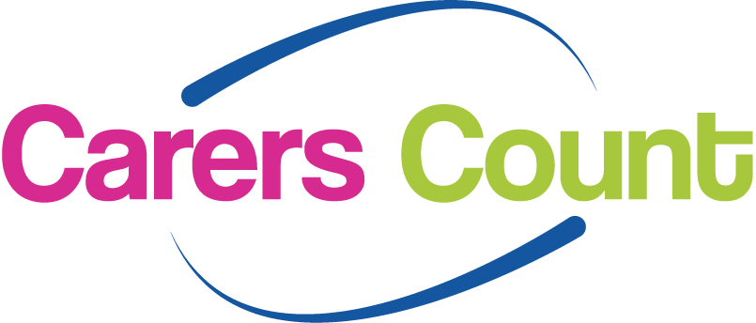

Carers facing cuts – will the Care Act make any difference ?

You are invited to a special event on

Wednesday 11th February 2015 7.00pm – 9.00pm at Northorpe Barn, Mirfield

Professor Luke Clements, a national expert on carers and the law, is returning to Kirklees (following his inspiring visit in July 2011). He has a well-earned reputation as an engaging, entertaining, and supremely knowledgeable speaker on the subject, and we are delighted that he has agreed to come back to update us on significant changes in the law that come into place in March 2015.

This event has been organised by the Learning Disability Carers Network for Kirklees, and carers of adults with learning disabilities will have guaranteed places if they apply by Friday 16th January 2015. At that point the list will be open to all carers of adults, regardless of the particular needs of the person they care for. There is a strict limit on numbers, and only those who have booked will be able to attend

The event is free of charge, although a small charge will be made for refreshments.

To book your place, please phone Lynne Heighway on 0300 012 0231
or email lynne.heighway@cloverleaf-advocacy.co.uk

